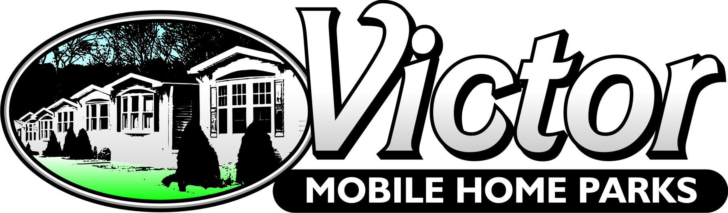

ANNUAL DRINKING WATER QUALITY REPORT FOR THE YEAR 2020
RIVERSIDE MOBILE HOME PARK
PUBLIC WATER SYSTEM #3400719

Introduction:
The NYS DOH has completed a source water assessment for this system, based on available information. Possible and actual threats to this drinking water source were evaluated. The state source water assessment includes a susceptibility rating based on the risk posed by each potential source of contamination and how easily contaminants can move throughout the subsurface to the wells. The susceptibility rating is an estimate of the potential for contamination of the source water, it does not mean that the water delivered to consumers is, or will become contaminated. See section “Are there contaminants in our drinking water?” for a list of the contaminants that have been detected. The source water assessments provide resource managers with additional information for protecting source waters into the future.

In compliance with State regulations, we are pleased to present to you this year’s Annual Quality Water Report. Our constant goal is to provide you with a safe and dependable supply of drinking water. We want you to understand the efforts we make to continually to improve the water treatment process and protect our water resources. We are committed to ensuring the quality of your water. If you have any questions about this report or concerning your water utility, or to obtain a copy of this report, please contact Linda Hannan, Victor Mobile Home Parks, Inc. at 585-924-1571. We want our customers to be informed about their water utility. We are proud to report that last year your water met all State drinking water health standards. This system falls under the jurisdiction of NYS Department of Health, Geneva District Office, 24 Pre-Emption Road, Geneva, NY 14456-1334, Telephone 315-789-3030.

Where Does our Water Come From?
As mentioned before, our water is derived from 2 drilled wells, approximately 30 feet deep, located on the north side of County Road 25. Both wells are located near the front of the park: One is east of the east entrance and the other is between the two entrances. Since November 1998 both wells have been linked together at a common point and chlorinated on site prior to distribution.
The source water assessment has rated these wells as having a medium-high susceptibility to microbial, halogenated solvents, herbicides and pesticides, metals, and other industrial contaminants. Susceptibility to nitrates was found to be high. These ratings are due primarily to the close proximity of a septic system, high intensity commercial land use, and significant fertilizer use/storage in relation to the wells. In addition, the wells draw from an unconfined aquifer of unknown hydraulic conductivity. While nitrates (and other inorganic contaminants) were detected in our water, it should be noted that all drinking water, including bottled drinking water, may be reasonably expected to contain at least small amounts of some contaminants from natural sources. The presence of contaminants does not necessarily indicate that the water poses a health risk. Also included is text that defines what is considered normal background for this particular area. Please note that, while the source water assessment rates our well as being susceptible to microbial, our water is disinfected to ensure that the finished water delivered into hour home meets the New York State drinking water standards for microbial contamination.

Are There Contaminants In Our Drinking Water?
In order to ensure that tap water is safe to drink the State Health Dept. and EPA prescribes Regulations which limit the amount of certain contaminants in water provided by public water systems. The Riverside Mobile Home Park routinely monitors for constituents in your drinking water according to Federal and State laws. We test your drinking water for numerous contaminants to include total coliform, inorganic compounds, nitrates, lead and copper, and also trihalomethanes, and haloacetic acids which are by-products of drinking water chlorination daily. The state allows us to test for some contaminants less than once per year because concentrations of these contaminants do not change frequently. See attached spread sheets for results of tests taken in 2020.
Do I Need To Take Special Precautions?
Drinking water, including bottled water, may reasonably be expected to contain at least small amounts of some contaminants. The presence of contaminants does not necessarily indicate that water poses a health risk. Some people may be more vulnerable to disease causing microorganisms or pathogens in drinking water than the general population. Immuno-compromised persons such as persons with cancer undergoing chemotherapy, persons who have undergone organ transplants, people with HIV/AIDS of other immune system disorders, some elderly, and infants can be particularly at from infections. These people should seek advice from their health care provided about their drinking water.

December 13, 2019 NYS Health Department issued a boil water order for RSP. This was due to filtration corrections we needed to make. Thornton Engineering designed a plan to facilitate this change. May, 2020 Plans were approved by the DOH for this project. The contact time pipe was installed and completed in September 2020. Thornton Engineering did pressure testing, flushing and water sampling was completed. The boil water was lifted.

SOURCES IN DRINKING WATER & HEALTH EFFECTS LANGUAGE

Barium: Discharge of drilling wastes; discharge from metal refineries; erosion of natural deposits. Some people who drink water containing Barium in excess of the MCL over many years could experience an increase in their blood pressure.

Lead: Corrosion of household plumbing systems; erosion of natural deposits. Infants and children who drink water containing lead in excess of the action level could experience delays in their physical. Children could show slight deficits in attention span and learning abilities. Adults who drink this water over many years could develop kidney problems or high blood pressure or mental development.

Copper: Corrosion of household plumbing systems; erosion of natural deposits; leaching from wood preservatives. Copper is an essential nutrient, but some people who drink water containing copper in excess of the action level over a relatively short amount of time could experience gastrointestinal distress. Some people who drink water containing copper in excess of the action level over many years could suffer liver or kidney damage.

Trihalomethanes: By-product of drinking water chlorination. Some people who drink water containing trihalomethanes in excess of the MCL over many years may experience problems with their liver, kidneys, or central nervous systems, and may have an increased risk of getting cancer.

Haloacetic acids: By-product of drinking water chlorination. Some people who drink water containing haloacetic acids in excess of the MCL over many years have an increased risk of getting cancer.

Uranium: Erosion of natural deposits. Some people who drink water containing uranium in excess of the MCL over many years may have an increased risk of getting cancer.

Combined R-226/228: Erosion of natural deposits. Some people who drink water containing radium 226 or 228 in excess of the MCL over many years may have an increased risk of getting cancer

Gross Alpha: Erosion of natural deposits. Certain minerals are radioactive and many emit a form of radiation known as alpha radiation. Some people who drink water containing alpha emitters in excess of the MCI over many years may have an increased risk of getting cancer.

Nitrate: Runoff from fertilizer use; leaching from septic tanks, sewage: Erosion of natural deposits. Infants below the age of six months who drink water contain nitrate in excess of the MCI could become seriously ill and, if untreated, may die. Symptoms include shortness of breath and blue-baby syndrome.

DEFINITIONS:

Maximum Contaminant Level (MCL): The highest level of a contaminant that is allowed in drinking water. MCLs are set as close to the MCLGs as feasible.

Maximum Contaminant Level Goal (MCLG): The level of a contaminant in drinking water below which there is no known or expected risk to health. MCLGs allow for a margin of safety.

Maximum Residual Disinfectant Level (MRDL): The highest level of a disinfectant allowed in drinking water. There is convincing evidence that addition of a disinfectant is necessary for control of microbial contaminants.

Milligrams per liter (mg/l): Corresponds to one part of liquid in one million parts of liquid (parts per million – ppm).

Micrograms per liter (ug/l): Corresponds to one part of liquid in one billion parts of liquid (parts per billion – ppb).

Piocuries per liter (pCi/L): A measure of the radioactivity in water.

WATER CONSERVATION:

Although our system has an adequate amount of water to meet present and future demands, there are a number of reasons why it is important to conserve water:

- Saving water conserves energy and the costs associated.
- Saving water reduces the wear and tear on tanks and water pumping equipment

With this in mind you can cut back on your water usage by following a few simple guidelines:

- Dishwashers and washing machines should be loaded to capacity.
- Turn off tap when brushing your teeth.
- Check every faucet and toilet for leaks. Just a slow drip can waste 15-20 gallons a day. Check your toilet for leaks by putting a few drops of food coloring in the tank, watch for a few minutes to see if the color shows up in the bowl you have a leak. Fixing these simple leaks can save hundreds of gallons of water.
- Check all outside hose faucets for leaking.
- During the winter months do not run your faucets to avoid from freezing the water pipes. Prepare for winter by making sure you heat tape on your water lines are working properly.

Thank you for allowing us to continue to provide you with quality drinking water this year.

